# E:\Users\simon.roche\AppData\Local\Microsoft\Windows\Temporary Internet Files\Content.Word\Evidencing the Impact of the Primary PE and Sport Premium Template 2019 7.3 Images_Page_1.jpg

Oakwell Rise Primary Academy

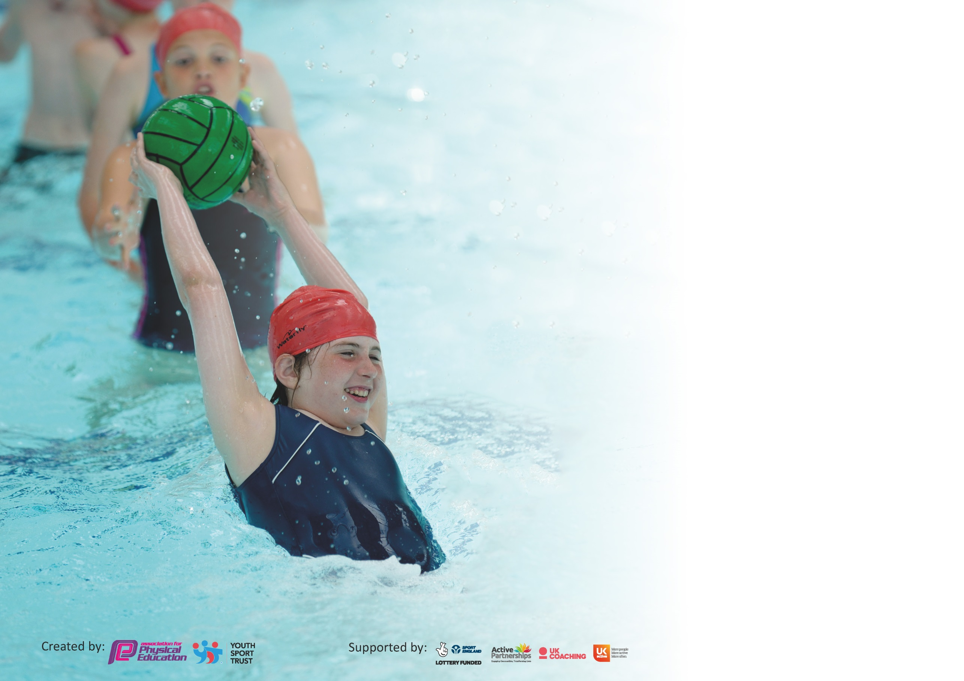

It is important that your grant is used effectively and based on school need. The [Education Inspection Framework](https://assets.publishing.service.gov.uk/government/uploads/system/uploads/attachment_data/file/843108/School_inspection_handbook_-_section_5.pdf) (Ofsted 2019 p64) makes clear there will be a focus on **‘whether leaders and those responsible for governors all understand their respective roles and perform these in a way that enhances the effectiveness of the school’**.

Under the [Quality of Education criteria](https://assets.publishing.service.gov.uk/government/uploads/system/uploads/attachment_data/file/843108/School_inspection_handbook_-_section_5.pdf) (p41) inspectors consider the extent to which schools can articulate their curriculum (INTENT), construct their curriculum (IMPLEMENTATION) and demonstrate the outcomes which result (IMPACT).

To assist schools with common transferable language this template has been developed to utilise the same three headings which should make your plans easily transferable between working documents.

Schools must use the funding to make **additional and sustainable** improvements to the quality of Physical Education, School Sport and Physical Activity (PESSPA) they offer. This means that you should

use the Primary PE and Sport Premium to:

* Develop or add to the PESSPA activities that your school already offer
* Build capacity and capability within the school to ensure that improvements made now will benefit pupils joining the school in future years

Please visit [gov.uk](https://www.gov.uk/guidance/pe-and-sport-premium-for-primary-schools) for the revised DfE guidance including the 5 key indicators across which schools should demonstrate an improvement. This document will help you to review your provision and to report your spend. DfE encourages schools to use this template as an effective way of meeting the reporting requirements of the Primary PE and Sport Premium.

We recommend you start by reflecting on the impact of current provision and reviewing the previous spend.

Schools are required to [publish details](https://www.gov.uk/guidance/what-maintained-schools-must-publish-online#pe-and-sport-premium-for-primary-schools) of how they spend this funding as well as on the impact it has on pupils’ PE and sport participation and attainment by the end of the summer term or by **31st July 2020** at the latest.

We recommend regularly updating the table and publishing it on your website throughout the year. This evidences your ongoing self-evaluation of how you are using the funding to secure maximum, sustainable impact. Final copy must be posted on your website by the end of the academic year and no later than the 31st July 2020. To see an example of how to complete the table please click [HERE](http://www.afpe.org.uk/physical-education/wp-content/uploads/afPE-Example-Template-Indicator-2018-Final.pdf).

Support for review and reflection - considering the 5 key indicators from DfE, what development needs are a priority for your setting and your pupils now and why? Use the space below to reflect on previous spend and key achievements and areas for development.

|  |  |
| --- | --- |
| Key achievements to date until July 2019: | Areas for further improvement and baseline evidence of need: |
| * Appointed PE and Physical Activity & Sport Lead in school * Increased number of competitions entered each year * Children from BPP working together and selected for teams * Increased number of extra-curricular activity clubs offered * Increase celebration of sporting successes as an item in our assemblies and through Facebook. * Raise aspirations from heroes/ events – * Increased time for PE lessons for the whole school * To use high quality venues as part of our competition schedules- English Institute Sport for Olympic Day, Cannon Hall for Orienteering, Barnsley Oakwell Stadium for Football, Dorothy Hymen Stadium for Athletics * Linked house points to a sporting theme – e.g. tug-o-war, dodgeball * High quality planning for teachers * Skipping workshops with equipment specific to age groups/ Key stages * Balance Bike training for EYFS and Year 1 * Bikeability sessions for Year 5. * More Barnsley Primary Partnership opportunities including Dance Festival and Cross Country * Taking part in Yorkshire Sport Trust Initiatives such as Beat the Street * Staff wearing PE kit on their PE days to lead by example. * Professional development opportunities for staff increased. * PE leads attended PE Conference. * Opportunities of physical activity at breakfast club. * Further opportunities of physical activity during play and lunch time with games and activities lead by staff. | * Apply for Active School Games Mark award * Continue with application for Primary PE and Sports Premium Awards * To continue to develop links with outside professionals and clubs * To further develop the website information * To increase provision for specific target groups i.e. girls, SEN, pupil premium. * To provide more sporting opportunities i.e. Trampolining, Ultimate Frisbee, Lacrosse and Badminton. * Development of family and community opportunities * Development of building character and resilience through sport, creativity and performing (as part of the Top Trumps Rewards) * Development of the daily mile and have more classes involved * To engage more children in active learning in other curriculum areas such as PHSE, Science, Maths and Writing. * PHSE programme focusing on healthy eating and exercise. * Make further links with other partnerships and trusts. |

|  |  |
| --- | --- |
| Meeting national curriculum requirements for swimming and water safety. |  |
| What percentage of your current Year 6 cohort swim competently, confidently and proficiently over a distance of at least 25 metres?  **N.B.** Even though your pupils may swim in another year please report on their attainment on leaving  primary school at the end of the summer term 2020. | 26% (2018/2019)  67% (2019/2020) |
| What percentage of your current Year 6 cohort use a range of strokes effectively [for example, front crawl, backstroke and breaststroke]? | 43% (2018/2019)  56% (2019/2020) |
| What percentage of your current Year 6 cohort perform safe self-rescue in different water-based situations? | 4.3% (2018/2019)  45% (2019/2020) |
| Schools can choose to use the Primary PE and Sport Premium to provide additional provision for swimming but this must be for activity **over and above** the national curriculum requirements. Have you used it in this way? | No |

**Action Plan and Budget Tracking**

Capture your intended annual spend against the 5 key indicators. Clarify the success criteria and evidence of impact that you intend to measure to evaluate for pupils today and for the future.

|  |  |  |  |  |
| --- | --- | --- | --- | --- |
| **Academic Year:** 2019/20 | **Total fund allocated:** £ 17,780.00 | **Date Updated: January 2020** | |  |
| **Key indicator 1:** The engagement of all pupils in regular physical activity – Chief Medical Officer guidelines recommend that primary school pupils undertake at least 30 minutes of physical activity a day in school | | | | Percentage of total allocation: |
| 57.6% |
| **Intent** | **Implementation** | | **Impact** |  |
| Your school focus should be clear what you want the pupils to know and be able to do and about  what they need to learn and to  consolidate through practice: | Make sure your actions to achieve are linked to your intentions: | Funding allocated:  £ 10,235.00 | Evidence of impact: what do pupils now know and what can they now do? What has changed?: | Sustainability and suggested next steps: |
| Ensuring all classes receive 2 hours of quality physical education per week.  EYFS pupils to have regular PE sessions as part of the moving and handling objectives and extensive opportunities to outdoor provision.  The Daily Mile to be introduced to the whole school.  Development of the outdoor areas on the playground including trim-trail, pirate ship, bikes, clamber sticks and sports arena.  To develop outdoor learning using Greenman Learning.  Development of extra-curricular provision to offer a wide range of physical activities to whole school. | All classes from EYFS – 6 receiving two sessions of physical education per week – including class teacher delivering one. Whole school timetable designed to ensure 2 sessions per class.  Every class to introduce the daily mile into their daily timetable.  Pirate ship, trim-trail, clamber sticks, bikes and sports arena on offer at breakfast club, playtime and lunches. As well as staff leading activities such as skipping, hop scotch.  Each class has 1 wild day per half term with Greenman Learning focused on outdoor learning linked to the whole curriculum to support and development skills needed in physical activity and sport.  Extra-curricular clubs offered including karate, drama, trampolining, multi-sports, yoga, | Play and Lunchtime Equipment: £5000  Greenman Learning: £4000  Transport for Greenman Learning: £1235 | All children are accessing 2 lessons of quality PE per week.  All teaching staff are delivering at least one lesson of PE per week to their class.  Children are being offered a wide range of activities throughout the school day.  Children have gained confidence in physical activities such as climbing and moving.    Evidence: PE timetable, planning for PE, extra-curricular clubs offered. | Continue to develop the active learning slots within the whole curriculum by sustaining the daily mile.  Continue to develop and sustain offering a wide range of clubs from EYFS to Year 6.  Staff to feel confident in delivering physical education  Identify new activities to deliver and offer via student council. |
| **Key indicator 2:** The profile of PESSPA being raised across the school as a tool for whole school improvement | | | | Percentage of total allocation: |
| 8.4% |
| **Intent** | **Implementation** | | **Impact** |  |
| Your school focus should be clear what you want the pupils to know and be able to do and about  what they need to learn and to  consolidate through practice: | Make sure your actions to achieve are linked to your intentions: | Funding allocated:  £1500.00 | Evidence of impact: what do pupils now know and what can they now do? What has changed?: | Sustainability and suggested next steps: |
| Lead teacher identified to lead physical education and school sport across whole school.  Lead to work alongside BPP sports lead to ensure quality and rich curriculum being delivered.  To enter further competitions beyond the BPP to engage wider net of children and offer further opportunities.  Sports Award Event in July for the BPP to celebration the success and effort of the children throughout the year.  Whole school sport events such as sports day, house competitions and events with the school games.  Development links with professional clubs and companies. | VS made lead of PE within school.  Implemented PHSE and Master Chef programmes across whole class to support promoting physical activity and healthy eating.  To attend School Game events to support offering more opportunity of engagement for all children.  Links made with PHSE programme to support encouraging healthy eating and physical activity. | Equipment: £500  Sports Award Ceremony: £500  Sports Mark Accreditation costs: £500 | Children are accessing two quality lessons of PE per week.  Children are accessing a wider range of extra-curricular activities.  Children are accessing wider physical opportunities during the whole school day.  Children are accessing further opportunities such as bikeability, balance bike.  All children participating in sports day which track and field events.  All children accessing house competitions. | To continue to develop extra-curricular activities offer to engage more children.  To continue to develop the relationship across the BPP.  To offer more opportunities of physical activity throughout the whole curriculum. |

|  |  |  |  |  |
| --- | --- | --- | --- | --- |
| **Key indicator 3:** Increased confidence, knowledge and skills of all staff in teaching PE and sport | | | | Percentage of total allocation: |
| 3.4% |
| **Intent** | **Implementation** | | **Impact** |  |
| Your school focus should be clear | Make sure your actions to | Funding  allocated:  £600.00 | Evidence of impact: what do | Sustainability and suggested |
| what you want the pupils to know | achieve are linked to your | pupils now know and what | next steps: |
| and be able to do and about | intentions: | can they now do? What has |  |
| what they need to learn and to |  | changed?: |  |
| consolidate through practice: |  |  |  |
| Continue to provide quality CPD delivered by PE specialist within school to all teaching and support staff.  Learning walks completed by PE lead to continue to offer support and confidence for the delivery and teaching of PE.  Wider network of staff to gain sports qualifications to introduce further activities into the curriculum. | 2 half inset days completed in September 2019  2 x staff meetings completed in Autumn 1 and 2.  2 x staff meetings completed in Spring 1  To deliver trampoline after school club. | CPD: £200  Equipment: £200  Staff Expenses: £200 | Increased confidence in staff across school to teach PE.  Growth in staff knowledge and confidence – two sessions of quality PE being delivered each week to each class. | Increased engagement and confidence of all staff to teach or support the delivery of PE.  Continue to develop the curriculum of activities offered within PE.  Develop the opportunities of activities offered as extra-curricular to all years. |
| **Key indicator 4:** Broader experience of a range of sports and activities offered to all pupils | | | | Percentage of total allocation: |
| 18.5% |
| **Intent** | **Implementation** | | **Impact** |  |
| Your school focus should be clear | Make sure your actions to | Funding  allocated:  £3290.00 | Evidence of impact: what do | Sustainability and suggested |
| what you want the pupils to know | achieve are linked to your | pupils now know and what | next steps: |
| and be able to do and about | intentions: | can they now do? What has |  |
| what they need to learn and to |  |  | changed?: |  |
| consolidate through practice: |  |  |  |  |
| Additional achievements:  To offer activities such as trampolining, ultimate Frisbee, lacrosse.  Build further connections across the Barnsley area with other partnerships and trusts to offer wider competition.  Offer a wider range of different activities as extra-curricular clubs.  School council to have half-termly meetings and discuss the provision of physical education and activity across school to support development.  Maintain and develop on good practice which was developed last year.  Jump Ahead OT programme delivered at play time and lunch time for all children offering gross and fine motor skill development. | Trampolining offered as after school club January – focusing on KS2.  Introduction of activities such as karate, yoga, trampoline, multi-sports, biking.  All pupils to take part in sports day, house competitions.  Bikeability offered to Year 5.  All EYFS and Year 1 given balance bike training.  Introduction of girls’ teams and girls’ competitions across the BPP.  Mixed teams across the BPP partnership entering BPP competitions and external competitions such as EFL Cup. | Balance Bike Training: £250  OT: £300  Equipment: £1000  Primary Sports Coaching: £1740 | Children given opportunity for success and engagement in competition.  Children given opportunity to develop further relationships and friendships across the trust.  Children given opportunity to try and experience new activities.  Developing SEN, pupil premium and girls engagement in activity.  Offering development of support programmes outside of typical learning environments. | Build upon competitions we are entering.  Offer further opportunities for activities across the whole school.  Continue to develop the engagement of key groups. |

|  |  |  |  |  |
| --- | --- | --- | --- | --- |
| **Key indicator 5:** Increased participation in competitive sport | | | | Percentage of total allocation: |
| 12.1% |
| **Intent** | **Implementation** | | **Impact** |  |
| Your school focus should be clear | Make sure your actions to | Funding  allocated:  £2155.00 | Evidence of impact: what do | Sustainability and suggested |
| what you want the pupils to know  and be able to do and about  what they need to learn and to  consolidate through practice: | achieve are linked to your  intentions: | pupils now know and what | next steps: |
| can they now do? What has |  |
| changed?: |  |
|  |  |  |
| To offer at least 2 competitive sporting competitions per half term for both key stages.  Focus on developing skills for events such as BPP competitions, sports day and house competitions.  To enter and compete in events which are not run by the BPP. | Autumn 1: Football (Ks2 girls competition and boys competition)  Cross Country: Ks1 mixed  Ks2 mixed  BPP joint school football team competition against other schools.  Intra school – tug of war whole school  Autumn 2: Netball (girls and boys mixed).  Intra-school – bench ball house point competition  Spring 1: Multi-skills competition for KS1 and KS2  Intra-school Competitions mapped out for the year.  Linked with School Games to enter competitions outside BPP.  Clear and high standard of planning focused on the events which we happen that half term. | T-shirts: £300  Medals/Trophies: £205  Transport to Tournaments: £500  Tournament Entry Fees: £500  Equipment: £500  Refreshments: £150 | Children are engaging and experience competitive activities outside of school.  Children are meeting new children in different environments.  Children are learning crucial life skills to transfer across disciplines. | Create relationships with other trusts.  Continue to develop engagement in wider competitive opportunities. |