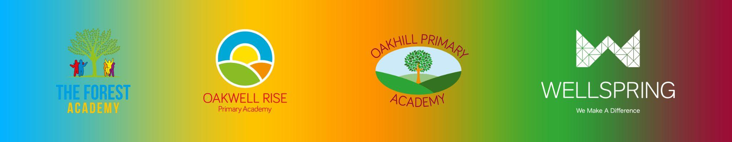

**BARNSLEY PRIMARY PARTNERSHIP GOVERNING BODY STATUTORY TRAINING AND DECLARATION OF INTERESTS 2024/25**

All governors have a statutory responsibility to read and understand Keeping Children Safe in Education, and declare a wide range of interests on an annual basis. Our Governors also complete Cyber Security and Prevent duty training on a regular basis. The table below indicates when this was last completed.

| **Governor Name** | **Declaration of Interests** | **Keeping Children Safe In Education** | **Prevent Refresher Training** | **Cyber Security Training** | **Declared interests** |
| --- | --- | --- | --- | --- | --- |
| Michael Sanderson (Chair) | 29.10.2024 | 29.10.2024 | 29.10.2024 | 29.10.2024 | * Hoyland Common Action Group, from 2005 * Trustee of various levels of the Methodist Church (Since 1980) * Director Forge Community Partnership; community partnership; since (since 1999) * Director Hoyland Common Action Group; community organisation; (since 2004) * Director Anvil Community CIC; community organisation; (since 2013) * Director Forge Parkside Centre; community organisation; (since 2017). * Director Spring Ahead CIC. (Since 2017) * Governor of Oakwell Rise, The Forest and Oakhill, Governor of Ebor Gardens and Victoria * Wife (Revd Eileen Sanderson) - Director of Forge Community Partnership (Since 2023) * Wife - Director of Forge Community Child Care CIC (2013) and Trustee of Elsecar Community Nursery since 2014 * Wife has been a trustee of various levels of the Methodist |
| Ken Mosley | 05.11.2024 | 05.11.2024 | 05.11.2024 | 05.11.2024 | N/A |
| Scott McHale | 20.10.2024 | 20.10.2024 | 20.10.2024 | 20.10.2024 | N/A |
| Mick Neal (Vice Chair) | 22.10.2024 | 22.10.2024 | 22.10.2024 | 22.10.2024 | * Barnsley Foodbank Partnership (2012 to date) * The Methodist Church Barnsley South (2016 to date) * Keresforth Primary School Barnsley since 2012 |
| Michala Wild | 05.11.2024 | 05.11.2024 | 05.11.2024 | 05.11.2024 | N/A |
| Dayo Oladiti | 25.11.2024 | 25.11.2024 | 25.11.2024 | 25.11.2024 | Astrea Academy Trust - Hatfield Primary Academy LGC.  Date: September 2024  Sheffield Hallam University/Planning and Initiatives Officer |
| Jane Kirkham | PENDING | PENDING | PENDING | PENDING | PENDING |
| Craig Aubrey | 21.10.2024 | 21.10.2024 | 21.10.2024 | 21.10.2024 | BMBC - community development officer  Wife works at Wellspring Academy Trust |
| Ella Copping | 04.11.2024 | 04.11.2024 | 04.11.2024 | 04.11.2024 | Wellspring, Class Teacher at The Forest Academy |
| Laura Barraclough | 04.10.2024 | 04.10.2024 | 04.10.2024 | 04.10.2024 | Employed by Wellspring Academy Trust |
| Jessica Jenkins | 05.11.2024 | 05.11.2024 | 05.11.2024 | 05.11.2024 | Sister works in a company which the Wellspring Academy Trust which have used for private occupational therapy work, which was approved by the previous EP. |
| Katie Pierce | 02/01/2025 | 02/01/2025 | 02/01/2025 | 02/01/2025 | N/A |
| Fr Paul Cartwright (Vice Chair) | PENDING | PENDING | PENDING | PENDING |  |
| Natalie Hardman | 06.11.2024 | 06.11.2024 | 06.11.2024 | 06.11.2024 | N/A |
| Governors who have left the LGB in the last 12 months: | | | | | |
|
| **Governor Name** | **Declared interests** | | | | |
| Fr Blair Radford | N/A | | | | |
|  |  | | | | |
|  |  | | | | |
|  |  | | | | |
|  |  | | | | |
|  |  | | | | |
|  | | | | | |